**Design Phase & Testing Phase Document : E-Ticketing**

**DOCUMENTATION OF USE CASE DIAGRAM**

● The actors in use case diagram are Passenger and System.

● The use cases are request for seat availability, make reservation, cancellation, check status and print report.

● The actors use the use case are denoted by the arrow.

● The request for seat availability use case is the request made by passenger for seat availability to the system.

● The make reservation use case is for making a reservation by passenger to the system.

● The cancellation use case is used to cancel the reservation by passenger. ● The Check status use case is to check status of the passenger regarding his ticket reservation/cancellation.

● The print report use case is to print the report of successful reservation. 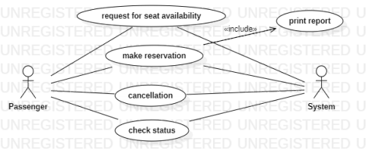**DOCUMENTATION OF CLASS DIAGRAM**

● **PASSENGER**- The passenger has attributes such as name, gender, email id, address and passenger_id. The passenger needs to fill the details that are required to book a ticket. After booking the person can view the status of the ticket booked.

● **TICKET**- The ticket has attributes such as source, destination, Date of booking, passenger_id and vehicle_no.

● **BUS**- The bus has attributes such as bus type, driver details, start_time and end_time. This is a medium of transportation passengers want to travel. ● **PAYMENT**- The payment has attributes such as payment_id, amount, mode of payment and no of tickets. Passenger makes the payment for the ticket he/she booked.

● **CANCELLATION**- The cancellation has attributes such as cancellation_id and refund amount. If a passenger requests for cancellation then it gets canceled and the amount will be refunded.

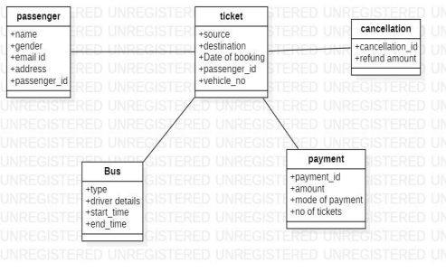

**DOCUMENTATION OF SEQUENCE DIAGRAM**

A sequence diagram represents the sequence and interactions of a given scenario. Sequence diagrams can capture most of the information about the system. Most object to object interactions and operations are considered events and events include signals, inputs, decisions, interrupts, transitions and actions to or from users or external devices.

An event also is considered to be any action by an object that sends information. The event line represents a message sent from one object to another, in which the “form” object is requesting an operation be performed by the “to” object. The “to” object performs the operation using a method that the class contains.

**Sequence diagram describes the sequence of steps:**

● Passenger are used to login the form. And then it verify the username and password.

● If the password and username are correct then applicants are used to login the filling details.

● Passenger are used to select and book the tickets.

● Now the E-Ticketing DataBase verify the filling Details.

● And then the E-Ticketing DataBase displays the ticket information. ● Incase of any sudden change of the plan, the applicant can cancel the ticket.

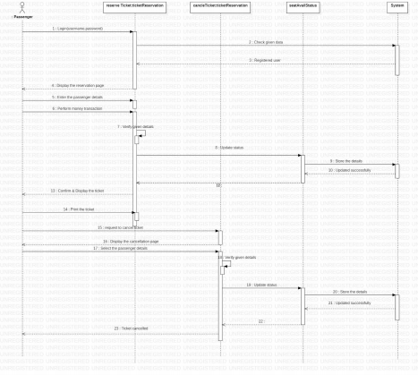**DOCUMENTATION OF COLLABORATION DIAGRAM**

• The passenger,seat booking,E-ticketing System,legacy system,seat details, cancel tickets are shown in sequence number

• The passenger first login theE-ticketing System and selects seats and books the seats .After that passenger selects the seats and request for cancellation and the seats are cancelled.

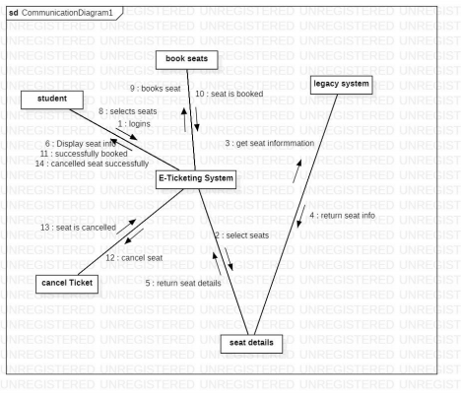**DOCUMENTATION OF STATE CHART DIAGRAM** ● The states of the E-Ticketing system are denoted in the state chart diagram. ● Login state represent authentication to login for E-Ticketing system. ● In this state, it checks whether the user has provided all the details that is required.

● User can check seats and book seats accordingly.

● If booked seat is cancelled, then seat info is updated.

● If seat is booked, user can log out.

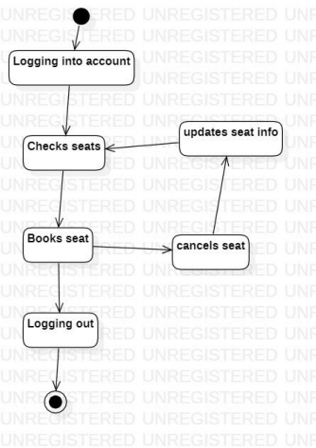

**DOCUMENTATION OF ACTIVITY DIAGRAM**

**•** The activities in the E-ticketing system are login, select details,request cancellation,confirm data.

**•** In the login activity applicant give username and password and then login into the e-ticketing system after that fill the passenger details that are required for application.

• Request merchant for cancellation and get confirmation of cancellation.

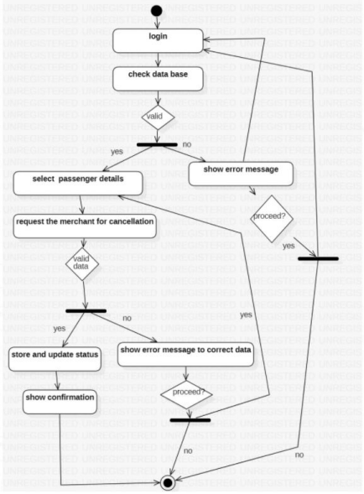**DOCUMENTATION OF COMPONENT DIAGRAM** • The components in the E-Ticketing system are passenger,account,book seat, cancel seat.

• passenger details ,account details,payment,seat info are dependent on E-Ticketing system are shown by the dotted arrow.

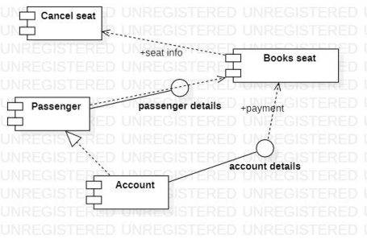**DOCUMENTATION OF DEPLOYMENT DIAGRAM**

The device node is E-Ticketing system and execution environment node are Passenger ,ticket,bus,payment, and cancellation.

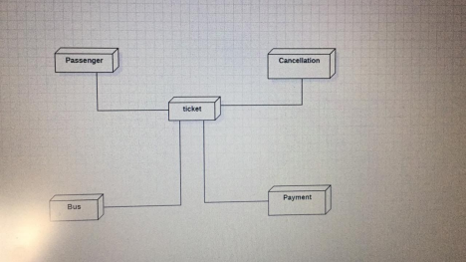**DOCUMENTATION OF PACKAGE DIAGRAM**

The four layers in the E-Ticketing system are passengers ,E-Ticketing system, organisation and cancellation.

• The Passengers-represents the passengers who booked tickets. • The E-Ticketing system layer-has actions such as displaying booked seats and available seats

• Organisation layer- authenticated employee only can access the technical services and grant the ticket cancellation.

• Cancellation layer-has actions such as displaying cancelled seats and refund amount

